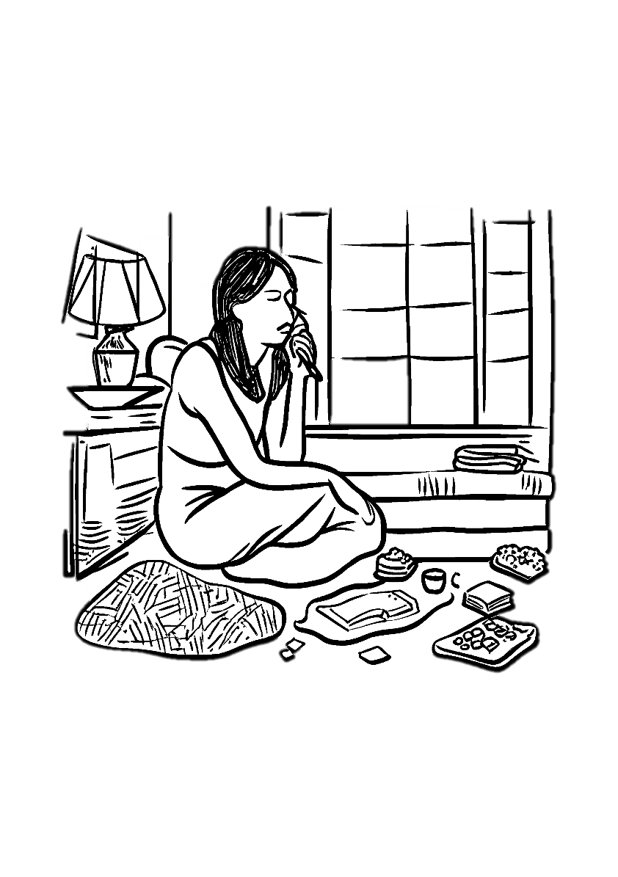

Gimme Gimme Gimme
  - Abba
Intro:
Rem Rem6- Doadd9 Rem
Rem Rem6- Doadd9 Rem
Rem Fa Lam Rem
Rem Fa Lam Rem
Rem
Half-past twelve
Sol
And I'm watching the late show in my flat all alone
Rem
How I hate to spend the evening on my own
Autumn winds
Blowing outside the window as I look around the room
And it makes me so depressed to see the gloom
Sim
There's not a soul out there
Solm7 Rem/La La
No one to hear my prayer
Rem Sib Do Rem
Gimme, gimme, gimme a man after midnight
Sib Rem Do Rem
Won't somebody help me chase the shadows away?
Rem Sib Do Rem
Gimme, gimme, gimme a man after midnight
Sib Rem Do Rem
Take me through the darkness to the break of the day
Rem Fa Lam Rem
Rem Fa Lam Rem
Movie stars
Find the end of the rainbow with a fortune to win
It's so different from the world I'm living in
Tired of TV
I open the window and I gaze into the night
But there's nothing there to see, no one in sight
There's not a soul out there
No one to hear my prayer
Gimme, gimme, gimme a man after midnight
Won't somebody help me chase the shadows away?
Gimme, gimme, gimme a man after midnight
Take me through the darkness to the break of the day
Rem Sib Do Rem
Gimme, gimme, gimme a man after midnight
Sib Rem Do Rem
Rem Sib Do Rem
Gimme, gimme, gimme a man after midnight
Sib Rem Do Rem
There's not a soul out there
No one to hear my prayer
Gimme, gimme, gimme a man after midnight
Won't somebody help me chase the shadows away?
Gimme, gimme, gimme a man after midnight
Take me through the darkness to the break of the day
Gimme, gimme, gimme a man after midnight
Won't somebody help me chase the shadows away?
Gimme, gimme, gimme a man after midnight
Take me through the darkness to the break of the day
Rem Fa Lam Rem
Rem Fa Lam Rem

